1. Install composer
   1. <https://getcomposer.org/Composer-Setup.exe>
   2. <https://www.niagahoster.co.id/blog/cara-install-composer/>
2. Install git bash, link download dibawah:
   1. https://git-scm.com/downloads
3. download script git
   1. <https://github.com/gurafwisandi/sms_gateway.git>
   2. Atau clone cmd ketik berikut ini:
   3. Git clone git@github.com:gurafwisandi/sms_gateway.git
4. Jika semua script sudah ada
5. Buka VSCODE -> menu terminal (topbar) -> new terminal
6. Ketik langkah-langkah berikut di terminal **(tanpa kutip semua)**
7. composer install
8. cp .env.example .env
9. php artisan key:generate
10. buka .env -> ubah DB_DATABASE sesuai yg dibuat di localhost (phpMyAdmin)

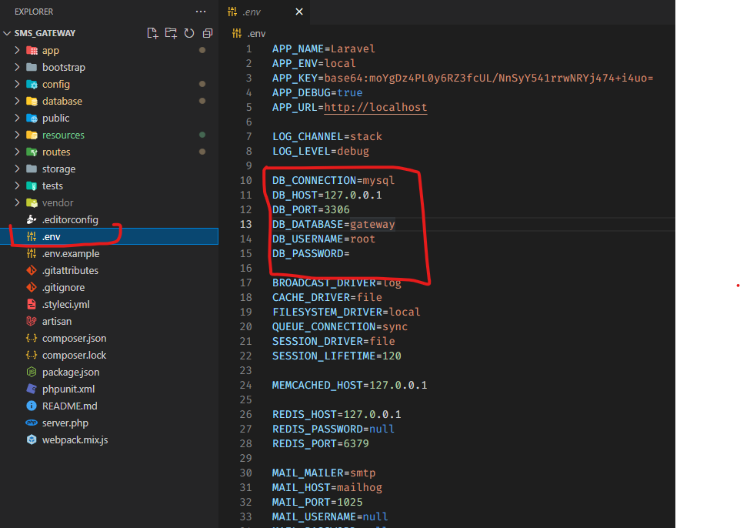

1. php artisan migrate:fresh --seed
2. php artisan serve